Biology 111 In-class Exam #3 March 27, 2013
For each question or statement select the best answer or completion. Mark your selections on a scantron form using a pencil. NOTE: a copy of the genetic code appears as the last page of this exam

- One difference between DNA and RNA is that while DNA contains the bases A,T,G, and C, the bases in RNA include:
a) A, B, C, and D b) A,T,G, and W c) A,C,G, and U d) A,T,C, and U e) E, F, G, and H

- Base-pairing in DNA is between:
a) A - U and G -C b) T - U and A -C c) A - T and C -G
d) A - A and T -T e) A - G and C -T

- Who first coined the word "cell"?
a) Hooke b) Aristotle c) Darwin d) Pasteur e) Virchow

- What instrument most advanced the understanding of cell structure and function?
a) microscope b) probe c) pasteur pipette d) bunsen burner e) petri dish,

- Which of the following is associated with rough endoplasmic reticulum?
a) nucleolus b) ribosomes c) lipid synthesis d) plasma membrane e) DNA

- Which of the following is associated with smooth endoplasmic reticulum?
a) nucleolus b) ribosomes c) lipid synthesis d) plasma membrane e) DNA

- Vesicles, formed at the endoplasmic reticulum, pass to the _____________ where molecules are modified and sorted before forming vesicles headed to final destinations.
a) brain b) golgi c) nucleus d) endotherm e) pancreas

- _________________ refers to vesicle fusion with the cell membrane and release of vesicle contents to outside of the cell.
a) exocytosis b) lymphoma c) type 2 diabetes d) type 1 diabetes e) none of these

- The mitochondria are the site of ...
a) endocytosis b) aerobic respiration c) photosynthesis d) glycolysis

- In 1870 ___________ first discovered nucleic acids (i.e. DNA and RNA) working with nuclei isolated from the wound puss of hospital patients.
a) Charles Darwin b) Rosalind Franklin c) Fred Griffiths
d) Friedrich Miescher e) Erwin Chargaff

- For the first half of the twentieth century the substance within the nucleus thought by scientists most likely to contain genetic information was....
- DNA b) lipids c) carbohydrates d) hydrocarbons e) protein

- In 1928 Fred Griffith, who worked with “rough” (avirulent) and “smooth” (virulent) strains of Streptococcus, discovered bacterial transformation when he combined ______________ and then injected this combination into mice.
- living rough and dead rough b) living smooth and dead smooth
c) living smooth and dead rough d) living rough and dead smooth
e) living smooth with living rough
- The molecular basis of bacterial transformation was discovered in 1944 by ....
- Avery, MacLeod, and McCarty b) Watson, Crick and Wilkins
c) Erwin Chargaff d) Laurel and Hardy
e) Nirenberg and Khorana

- The molecular basis of bacterial transformation was discovered by combining dead smooth Streptococcus with ___________ which was then show to block transformation.
- proteinase b) DNAase c) RNAase d) lipids e) carbohydrates

- The definitive demonstration of DNA as the molecule genetic information occurred in 1953 when Alfred Hershey and Martha Chase combined...
a) radioactive phages with mice b) radioactive phages with bacteria
c) radioactive phages with dead virulent bacteria d) radioactive phages with dead avirulent bacteria
e) radioactive phages radioactive phages

- The discovery that DNA always consisted of equal proportions of A and T as well as equal proportions of G and C was discovered in 1950 by....
- Friedrich Miescher b) Francis Crick c) Erwin Chargaff
d) Charles Darwin e) Fred Griffiths

- The discovery of the double stranded structure of DNA was critically aided by the data of Rosalind Franklin who studied DNA using ....
a) X-ray crystallography b) radiocarbon dating c) chromatography
d) lithography e) bulimia

- The successful model fitting these results to the “double helix” structure of DNA was built by ...
- Francis Crick b) Maurice Wilkins c) Rosalind Franklin
d) James Watson e) both Crick and Watson

- The double helix structure of DNA immediately (and correctly) suggested that mechanism of DNA replication must be ...
- reductive b) restrictive c) oxidative
d) semi-conservative e) neo-conservative

- In 1962 the Nobel Prize “for their discoveries concerning the molecular structure of nucleic acids and its significance for information transfer in living material” went to ....
- James Watson b) Francis Crick c) Watson, Crick, and Erwin Chargaff
d) Watson, Crick, and Rosalind Franklin e) Watson, Crick, and Maurice Wilkins

- The genetic code was worked out in the 1960s by...
a) Penn and Teller b) Watson and Crick c) Avery, MacLeod, and McCarty
d) Laurel and Hardy e) Nirenberg and Khorana

- The method used to decipher the genetic code consisted of combining the rest of the molecular machinery of translation from bacteria together with a man-made (artificial) _____________.
- tRNA b) mRNA c) rRNA d) DNA e) amino acid

- The “codons” of the genetic code consist of __________ in a row.
- three nucleotides b) three to five nucleotides c) one to ten amino acids
d) three proteins e) three to five proteins

- The genes in DNA “work” to control cell and organism biology through transcription and translation. The first of these (transcription) refers to ....
a) replication of DNA b) copying DNA into protein c) copying DNA into RNA
d) copying protein into DNA e) copying RNA into DNA

- In a eukaryote cell, where does transcription occur?
- in the nucleus b) in the mitochondria c) in the cytoplasm
d) in the cell wall e) in the endoplasmic reticulum

- In a eukaryote cell, where does translation occur?
a) in the nucleus b) in the mitochondria c) in the cytoplasm
d) in the cell wall e) in the endoplasmic

- Consider the following mRNA sequence: AUGAUCACCAAUCGU. What would the resulting protein sequence be? Assume the sequence begins a coding sequence.
- TACTAGTGGTTAGCA b) UACUAGUGGUUAGCA c) GGTTAGCATACTAGT
d) met,ile,thr,asn,arg e) met,tyr,phe,pro,ile

- Which amino acid is designated by the fewest number of codons?
a) arginine b) tryptophan c) cysteine d) tyrosine e) valine

- In order to metabolize lactose, the intestinal bacteria E. coli must...
- be exposed to an oxygen rich environment b) induce (i.e. turn on) three genes
c) encyst and become dormant for a period d) past through binary fission first
e) be symbiotically assisted by another bacteria

- The lac operon consists, in order, of...
- operator, promoter, and structural genes b) structural genes, operator, and promoter
c) structural genes, promoter, and operator d) promoter, structural genes, and operator
e) promoter, operator, and structural genes

- Binary fission refers to cell division as it occurs in _________________ cells.
- fungi b) animal c) prokaryotes d) eukaryotes e) plant

- The four phases of mitosis are, in order, _____________________.
- prophase, anaphase, metaphase, and telophase
b) anaphase, metaphase, prophase, and telophase
c) prophase, metaphase, anaphase, and telophase
d) prophase, telophase, metaphase, and anaphase
e) prophase, anaphase, metaphase, and telophase

- During prophase, ____________.
- chromosomes decondense b) chromosomes condense c) chromatids separate
d) centromeres move to the equator e) a cell plate forms

- During anaphase, ____________.
a) chromosomes decondense b) chromosomes condense c) chromatids separate
d) centromeres move to the equator e) a cell plate forms

- A karyotype is _________________.
- an eye-friendly font b) a bacterium requiring an O₂ free environment
c) a bacterium requiring an O₂ rich environment d) a pair of homologs
e) an illustration of cell chromosomes

- With the exception of your sex cells, the cells of your body are
- devoid b) diploid c) haploid d) polyploid e) both a and d

- By contrast, your gametes (sex cells) are __________.
- devoid b) diploid c) haploid d) polyploid e) both a and d

- Prophase I (of Meiosis I) differs from prophase (of mitosis) in that __________.
- crossing over occurs b) homologous chromosomes condense together
c) a cell plate forms d) none of these e) both a and b

- Separation of chromatids occurs in ________ during meiosis.
a) prophase II b) anaphase I c) anaphase II d) prophase I e) diaphase II

- Separation of homologous chromosomes occurs in ________ during meiosis.
a) prophase II b) anaphase I c) anaphase II d) prophase I e) diaphase II

- At the end of meiosis there are four cells which are _____________.
- diploid with unreplicated chromosomes b) diploid with replicated chromosomes
c) both haploid and diploid d) haploid with unreplicated chromosomes
e) haploid with replicated chromosomes

- Sexual reproduction occurs in all groups of eukaryotic organisms. It appears to offer a clear advantage over asexual reproduction in that it ...
a) spreads beneficial mutations within populations
b) prevents disease
c) results in bigger offspring
d) is more rapid than asexual reproduction
e) increases the likelihood of reproduction

- Humans, have a so-called ______________ life cycle in which mitosis only occurs in diploid cells.
a) diploid b) polyploid c) haploid d) aneuploid e) triploid

- Gregor Mendel (1822-1884) has come to be thought of as the father of modern ______________.
a) genetics b) biochemistry c) cell biology d) botany e) biotechnology

- Various forms of a specific gene are referred to as _________.
a) gene recess b) allele c) autosome d) diploid e) locus.

- A monohybrid cross is one in which ___________.
- there is only one parent (i.e. self fertilization occurs) b) both parents are true-breeding
c) only one offspring is produced d) the parents differ in one characteri
e) the parents differ in one or more characteristics

- When Mendel crossed true-breeding purple flowered peas with true-breeding white flowered plants, the resulting progeny (i.e. the F1 generation) were ____________ .
- all white b) all purple c) purple or white in a ratio of 3:1
- purple and white in a ratio of 1:1 e) all non-viable

- The term genotype refers to the _______________ of an individual.
a) genetic content b) characteristic appearance c) age profile d) age e) viability

- Assuming A is dominant over a, a cross of an Aa and Aa individual should result in progeny with a phenotype(s) ______...
a) in a 3:1 ratio b) conferred by the dominant allele only
c) conferred by the recessive allele only d) in a 1:1 ratio e) unlike either parents

- In Mendel’s dihybrid cross experiment the F2 generation was a mixture of phenotypes in a ratio of ________ .
a) 9:3:3:1 b) 3:1 c) 1:1 d) 2:1 e) 5:1

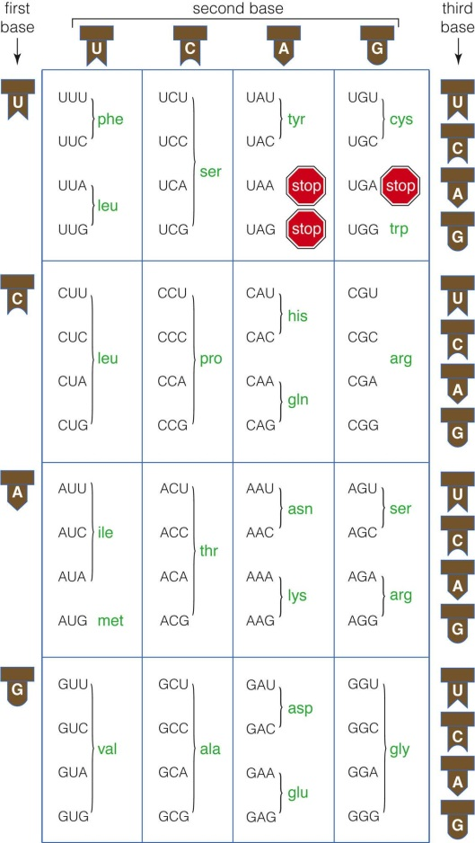

Make sure you have correctly placed your name and the the lab section you are registerd in on your scantron form!

